MAT110_MIDTERM_FAQ_SPRING 2025_SKY
https://docs.google.com/document/d/1IHVQQyUl9BOzXx1ToSMgq2mIJ3C_bkN926_VTK7VAOQ/edit?usp=sharing

📢Collected from the comments in Google Classroom and emails (Sections 16, 19, 20)
Thanks to the students who asked these questions—you should thank them too!
Keep asking more questions and I'll add those here. These are quick responses ,so if you find any discrepancy here, let me know. You can Comment/Suggest in the FAQ google doc directly, or feel free to email me. I'll try to keep updating ASAP. For any confusion or detailed answer please refer to the main course info google doc.
📢 Reminder: Check the Google Classroom for updates, and refer to the Google Doc & recorded review sessions for detailed explanations.
🚀 Good luck with your midterms!Best wishes,
Sakal Roy

1. Can we solve limit problems using L'Hôpital’s Rule, or do we have to use algebra?
📌 Answer:
See the resources shared in Google Classroom or check this link:
🔗 L'Hôpital’s Rule Explanation
In short:
- L'Hôpital’s Rule applies to lim (x→a) [f(x)/g(x)] only if the expression forms an indeterminate case as x → a.
- When L'Hôpital’s Rule fails:
  - If f(x) or g(x) is not differentiable at x = a.
  - If lim (x→a) [f(x)/g(x)] does not exist (DNE).
  - If applying L'Hôpital’s Rule leads to circular reasoning.
📌 Check the examples in the review session recording & Google Docs.

2. Where can we find the solutions to the suggested practice problems?
📌 Answer:
1️⃣ The Howard Anton solution manual is linked in the beginning of the Google Doc (see "Reference Books").
2️⃣ Use the online solvers linked in the course info Google Doc.

3. Rolle's Theorem: Should we differentiate using the definition or the standard derivative rules?
📌 Answer:
Use the normal derivative rules. There's no need to differentiate using the definition. This was mentioned at the end of Exam Review Session 1 (watch around 2:39 in the recording).

4. If no specific side is mentioned in a limit problem, should we check both one-sided limits separately?
📌 Answer:
✅ The safe method is to calculate both one-sided limits (x → a⁺ and x → a⁻) and compare them.
✅ You can directly calculate the two-sided limit only if the same function applies for both x → a⁺ and x → a⁻.

5. If a specific side is mentioned (e.g., x → 0⁺ or x → 0⁻), can we directly use 1/x = 0?
📌 Answer:
✅ If a specific side is mentioned (x → a⁺ or x → a⁻), only that part needs to be calculated.
❌ You cannot directly replace 1/x with 0 in expressions of the form:
- lim (x→ ±∞) [f(x)]^g(x)
📌 In such cases, you need to use logarithms first.

6. Will parametric differentiation and differentiation of inverse functions be included?
📌 Answer:
✅ Yes. The techniques of differentiation practice sheets contain everything you need.

7. Will successive differentiation, gradient, and tangent be included?
📌 Answer:
✅ No, these topics are in a separate part and are not included this semester.

8. Where can I find you for in-person consultation before the midterm?
📌 Answer:
📍 I might be at BRACU MNS around 12:00 PM, 18 march, 2025 (TUESDAY).
However, since the midterm starts on 18 march, 2025 (TUESDAY), consultation in the teachers' zone might be restricted.
📌 Email me when you're there and wait for my reply in case of an emergency meeting.

9. Problems that seems difficult to the students:
📌 Limit & Continuity Problems:
For Limit problems: 8,11,12:
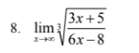
https://www.emathhelp.net/calculators/calculus-1/limit-calculator/?f=%28%283x%2B5%29%2F%286x-8%29%29%5E%281%2F3%29&var=&val=inf&dir=
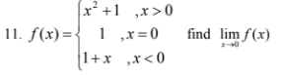
LHL:
https://www.emathhelp.net/calculators/calculus-1/limit-calculator/?f=1%2Bx&var=&val=0&dir=-
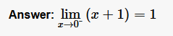
RHL:
https://www.emathhelp.net/calculators/calculus-1/limit-calculator/?f=x%5E2+%2B1&var=&val=0&dir=%2B
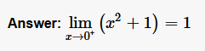
$Since, LHL=RHL,so,\lim_{x→0}=1$
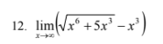
https://www.emathhelp.net/calculators/calculus-1/limit-calculator/?f=sqrt%28x%5E6%2B5x%5E3%29-x%5E3&var=&val=inf&dir=
See recording of Exam Review Session 1.
Also, given in Course info google doc as HOWARD ANTON EXAMPLES.
For continuity problems: 6,7,8,11,12:
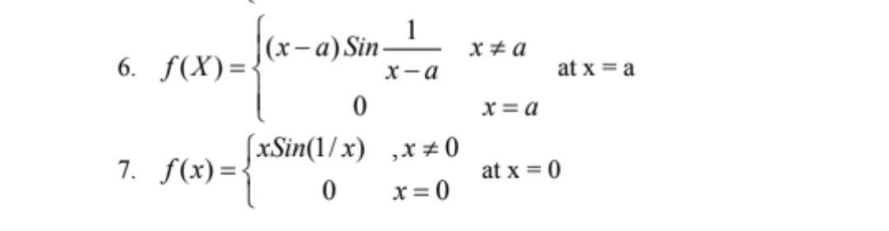
See the squeeze theorem video from google classroom (also its in course info google doc).
https://www.youtube.com/watch?v=7TGgWs_qCWY&list=PLlwePzQY_wW8P_I8BFgm0-upywEwTKd8_&index=14&t=5s
A problem similar to Continuity P7 is solved there in detail.
Continuity P6 is similar to P7. In P6, you may use x-a= h to get an exactly similar type of function (with h instead of x) as continuity P7.
For both problems do 2 one-sided limits separately and focus on inequality properties.
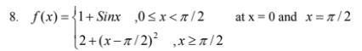
See recording of Exam Review Session 1.
Use the continuity theorem:
$f(x) is continuous at x=a only if:f(a)=\lim_{x→a}f(x)$
📢 Input value of x as radian, not in degree.
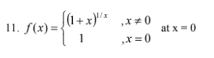
See recording of Exam Review Session 1.
Use the continuity theorem:
$f(x) is continuous at x=a only if:f(a)=\lim_{x→a}f(x)$
📢 You’ll be in DANGER (mathematically) if:
You Input value of x=0 and write $\frac{1}{0}=∞ or 1^{∞}=1$
📢USE LOGARITHM AND L'HOPITAL'S LAW TO SAVE YOUR MATHEMATICAL LIFE.
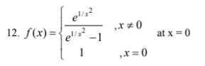
See recording of Exam Review Session 1.
Use the continuity theorem:
$f(x) is continuous at x=a only if:f(a)=\lim_{x→a}f(x)$
📢 You’ll be in DANGER (mathematically) if:
You Input value of x=0 and write $\frac{1}{0}=∞ or e^{∞}=∞$
📢USE LOGARITHM AND L'HOPITAL'S LAW TO SAVE YOUR MATHEMATICAL LIFE.
📌 Differentiability: 1(ii), (iii), (iv), 3
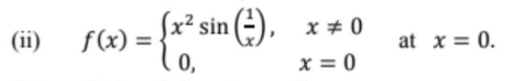
USE ANY VALID DEFINITION OF DERIVATIVE to check for DIFFERENTIABILITY:
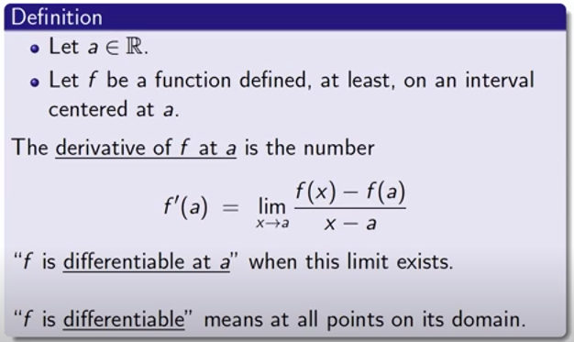
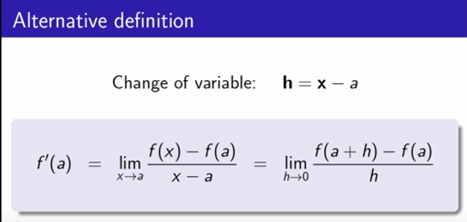
See here:
https://www.youtube.com/watch?v=7vhux5TLRmQ&list=PLlwePzQY_wW8qiZD6XYqCnibdY37ygbx7&index=3&t=1s
https://www.youtube.com/watch?v=eNcg9cKzV1Q&list=PLlwePzQY_wW8qiZD6XYqCnibdY37ygbx7&index=3
Solution:
$We’ve to calculate:\lim_{x→0}\left[\frac{f(x)-f(0)}{x-0}\right]$
$f(0)=0 [ Since, f(x) = 0 for x=0 ]⇒f(0)=0$
LHD:
$\lim_{x→0^{-}}\left[\frac{f(x)-f(0)}{x-0}\right]=\lim_{x→0^{-}}\left[\frac{x^{2} sin \left(\frac{1}{x}\right) -0}{x-0}\right]=\lim_{x→0^{-}}\left[\frac{x^{2} sin \left(\frac{1}{x}\right)}{x}\right]$ $[ Since, f(x) = x^{2} sin \left(\frac{1}{x}\right) for x≠0 ]$
RHD:
$\lim_{x→0^{+}}\left[\frac{f(x)-f(0)}{x-0}\right]=\lim_{x→0^{+}}\left[\frac{x^{2} sin \left(\frac{1}{x}\right) -0}{x-0}\right]=\lim_{x→0^{+}}\left[\frac{x^{2} sin \left(\frac{1}{x}\right)}{x}\right]$ $[ Since, f(x) = x^{2} sin \left(\frac{1}{x}\right) for x≠0 ]$
After simplifying this will turn out as: $\lim_{x→0^{-}}x sin \left(\frac{1}{x}\right) and \lim_{x→0^{+}}x sin \left(\frac{1}{x}\right)$,.
Since sin (1/x) and cos(1/x) share similar oscillatory nature, their limit can also be done in a similar way as the squeeze theorem video shows.
USE ANY VALID DEFINITION OF DERIVATIVE to check for DIFFERENTIABILITY:


See here:
https://www.youtube.com/watch?v=7vhux5TLRmQ&list=PLlwePzQY_wW8qiZD6XYqCnibdY37ygbx7&index=3&t=1s
https://www.youtube.com/watch?v=eNcg9cKzV1Q&list=PLlwePzQY_wW8qiZD6XYqCnibdY37ygbx7&index=3
Solution: https://www.mathsisfun.com/calculus/differentiable.html

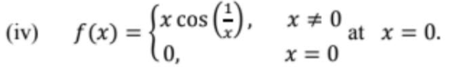
USE ANY VALID DEFINITION OF DERIVATIVE to check for DIFFERENTIABILITY:


See here:
https://www.youtube.com/watch?v=7vhux5TLRmQ&list=PLlwePzQY_wW8qiZD6XYqCnibdY37ygbx7&index=3&t=1s
https://www.youtube.com/watch?v=eNcg9cKzV1Q&list=PLlwePzQY_wW8qiZD6XYqCnibdY37ygbx7&index=3
Solution:
$We’ve to calculate:\lim_{x→0}\left[\frac{f(x)-f(0)}{x-0}\right]$
$f(0)=0 [ Since, f(x) = 0 for x=0 ]⇒f(0)=0$
LHD:
$\lim_{x→0^{-}}\left[\frac{f(x)-f(0)}{x-0}\right]=\lim_{x→0^{-}}\left[\frac{x cos \left(\frac{1}{x}\right) -0}{x-0}\right]=\lim_{x→0^{-}}\left[\frac{x cos \left(\frac{1}{x}\right)}{x}\right]$ $[ Since, f(x) = x cos \left(\frac{1}{x}\right) for x≠0 ]$
RHD:
$\lim_{x→0^{+}}\left[\frac{f(x)-f(0)}{x-0}\right]=\lim_{x→0^{+}}\left[\frac{x cos \left(\frac{1}{x}\right) -0}{x-0}\right]=\lim_{x→0^{+}}\left[\frac{x cos \left(\frac{1}{x}\right)}{x}\right]$ $[ Since, f(x) = x cos \left(\frac{1}{x}\right) for x≠0 ]$
After simplifying this will turn out as: $\lim_{x→0^{-}}cos \left(\frac{1}{x}\right) and \lim_{x→0^{+}}cos \left(\frac{1}{x}\right)$,.
Since sin (1/x) and cos(1/x) share similar oscillatory nature, their limit can also be done in a similar way as the squeeze theorem video shows.
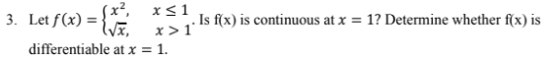
CONTINUITY:
Use the continuity theorem:
$f(x) is continuous at x=a only if:f(a)=\lim_{x→a}f(x)$
DIFFERENTIABILITY:
USE ANY VALID DEFINITION OF DERIVATIVE to check for DIFFERENTIABILITY:


See here:
https://www.youtube.com/watch?v=7vhux5TLRmQ&list=PLlwePzQY_wW8qiZD6XYqCnibdY37ygbx7&index=3&t=1s
https://www.youtube.com/watch?v=eNcg9cKzV1Q&list=PLlwePzQY_wW8qiZD6XYqCnibdY37ygbx7&index=3
Solution:
$We’ve to calculate:\lim_{x→1}\left[\frac{f(x)-f(1)}{x-1}\right]$
$f(1)=1^{2} [ Since, f(x) = x^{2} for x≤1 ]⇒f(1)=1$
LHD:
$\lim_{x→1^{-}}\left[\frac{f(x)-f(1)}{x-1}\right]=\lim_{x→1^{-}}\left[\frac{x^{2}-1}{x-1}\right]$ $[ Since, f(x) = x^{2} for x≤1 ]$
https://www.emathhelp.net/calculators/calculus-1/limit-calculator/?f=%28x%5E2-1%29%2F%28x-1%29&var=&val=0&dir=-
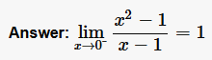
RHD:
$\lim_{x→1^{+}}\left[\frac{f(x)-f(1)}{x-1}\right]=\lim_{x→1^{-}}\left[\frac{\sqrt{x}-1}{x-1}\right]$ $[ Since, f(x) = \sqrt{x} for x>1 ]$
https://www.emathhelp.net/calculators/calculus-1/limit-calculator/?f=sqrt%28x%29&var=&val=0&dir=%2B
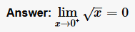
$Since,LHD≠RHD,⇒\lim_{x→1}\left[\frac{f(x)-f(1)}{x-1}\right] DNE ⇒f(x) is not differentiable at x=1.$

